Create your own flower
- Students must trace and cut out 8 petals and 6 sepals, from the template of a petal and sepal created by the teacher.
- Each student will need 5 pieces of wire & floral tape. (1 per petal & 1 for the pistil & ½ per stamen)
- Put 1/2 piece of wire per petal & hot glue 2 petals to sandwich the wire together. (end up with 4 petals)
- Do the same thing for the sepals. (end up with 3 sepals)
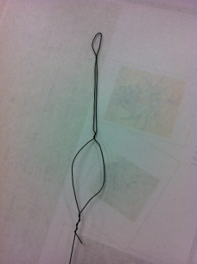
- Pistil is 1 piece of wire shaped in the pistil pattern. Small circle on top then rounded toward the center (twisting wire). After that you must floral tape the pistil.

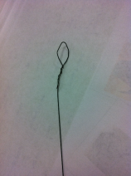
- Stamen is ½ piece of wire shaped in the stamen patter. Small circle on top then straight all the way down & floral tape.

- Place one Stamen on each side of the pistil, then add the petals and the sepals. Floral tape all together.
- Bend the petals to shape the flower, and spray with perfume to add a scent!

