Making & Packaging Dog Treat Lab
Procedures:
- Divide into groups. Each group will be given a recipe and all the ingredients needed to make your dog treat.
- Your group will need to make the treat then develop a package for your treat.
- Your packaging will need to have:
  - A product name
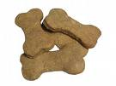
  - A manufacturer’s name
  - A phone number/address for the manufacturer.
(Use school info)
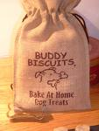
23440 Cinco Ranch Blvd.
Cinco Ranch, TX 77433
281-237-5213
  - Ingredient Panel
  - Feeding guidelines
  - Expiration date
  - Special features
  - How to store your product
  - Price
- Use your creative mind to decorate your package or come up with a catchy slogan.
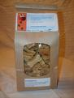
Example treat _____/15 pts
A product name _____/5 pts
A manufacturer’s name _____/5 pts
Manufacturer info. _____/5 pts
Ingredient Panel _____/5 pts
Feeding guidelines _____/5 pts
Expiration date _____/5 pts
Special features _____/5 pts
How to store your product _____/5 pts
Price _____/5 pts
Slogan _____/10 pts
Creativity/Neatness _____/15 pts
Participation _____/25 pts

