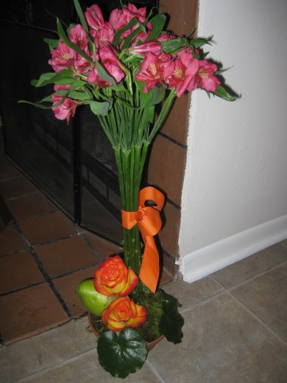
Materials Needed
- 10 stems Alstromeria aka Peruvian lillies
- 2 stems Roses
- 1 Fruit (Apples and pears work best, and organic tends to look prettier)
- 1 wooden pick
- 1 block wet foam (oasis)
- Ribbon (1.5 yds makes a nice bow)
- 1 small bag of floral moss
- Plastic Terra-cotta shallow dish
- A touch of greenery is optional
Instructions
- Removes all leaves from alstromeria and roses
- Remove any damaged petals
- Soak you oasis foam about 1/3 block if you need extra you can always soak more (remember to just set it on top of the water, it will soak itself. Forcing it to soak creates air bubbles)
- Cut 1/3 of a block of foam. If you want the ground to be flat cut this in half and put one piece in the container. Break the other pieces up and put around the center block to fill in holes to put moss on. You can also shape the foam to create a mound. Cut off about 2/3 of the small block you originally cut and the shave some off of the edges of the foam.
- Gather all the alstromeria together. You want to simulate a dome foam on top so the flowers on the outside of the bunch should be slightly shorted the one in center. Decide on a good height and cut the stems at a slight angle. I like the flowers to be somewhere around 12-15 inches in height depending on the size of the container. A good rule of thumb is 1.5 – 2 times the width of the container.
- At this point you can push all the flowers into the foam at one time very carefully. If you turn the flowers to much the hole in the foam will be too loose. You can also stick the flowers in one at a time using radial stem placement so the flowers all seem to be coming from one place. You should have at least one inch of stem into the foam.
- At this point you want to soak your moss and cover the base. Make sure no moss is hanging outside the container or it will drip and potentially ruin the table you are using. If you need take some thin wire, a 28 gauge work pretty good, cut a 2 inch piece and fold to make a hair pen. This will guarantee your moss stays in place.
- Once the alstromeria is in cut the rose pretty short. The need stem to stick in the container but you want to do your best to hide the stem. I would cut one at about 2” and the other at about 4”. Position them so one is higher than the other and use a slight angle. You may need to move a little piece of moss to stick your roses in. The stems are thick though so they should go through the moss no problem.
- Stick a wooden pick in the bottom of the fruit. Again make sure the pick is short as you do not want it to be seen and insert it into the foam next to the roses.
- Finally tie a bow around your alstromeria to bring all the stems together to get a dome shape rather than a fan.
- Make sure the foam and moss stays wet and your design should last for about a week

