Anther-
Filament-
Petals-
Sepal-
Stigma-
Style-
Ovary-
Calyx-
Pistil-
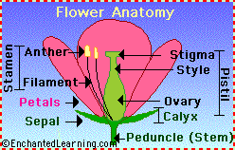
Peduncle (Stem)-

