To start you will need to gather a few swag making supplies
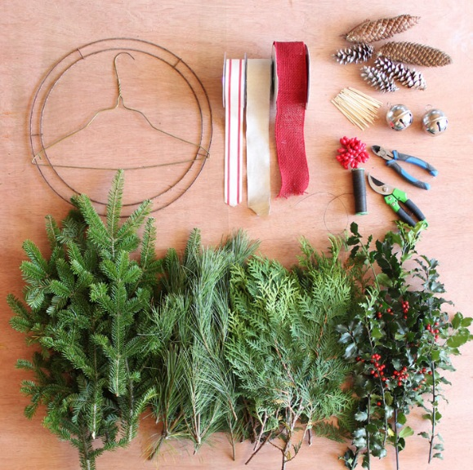
- Coat hanger (the wreath ring is for tomorrows project)
- Balsam Fir, Pine, Cedar, holly clippings (picture in that order)
- Garden pruners
- Floral wire
- Wire snippers
- Decorations/ floral picks
- Floral sticks (cut skewers work too)

How to Make a Christmas Swag
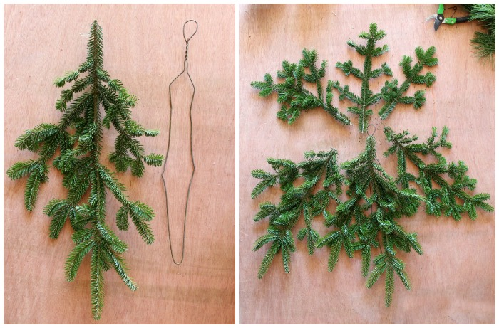
1.) Push the sides of the coat hanger to the centre, stretching it into a long line. Using a pair of pliers, bend the hook of the hanger into a loop for easy hanging.
2.) Start with a long sturdy fir branch that is approx 18″ long, for the swag base.
3.) Layer the bottom branch with two additional sturdy pieces approx 16″ long.
4.) Make a similar arrangement of three branches, with the ends pointing in the opposite direction measuring approx 10- 12″ long.
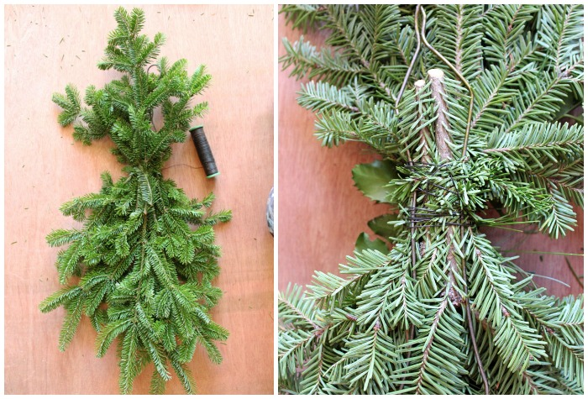
5.) Twist the end of the floral wire around the coat hanger to secure.
6.) Layer the six fir branches together on top of the coat hanger. Twist the wire around the entire bunch of greenery multiple times, securing it to the hanger.
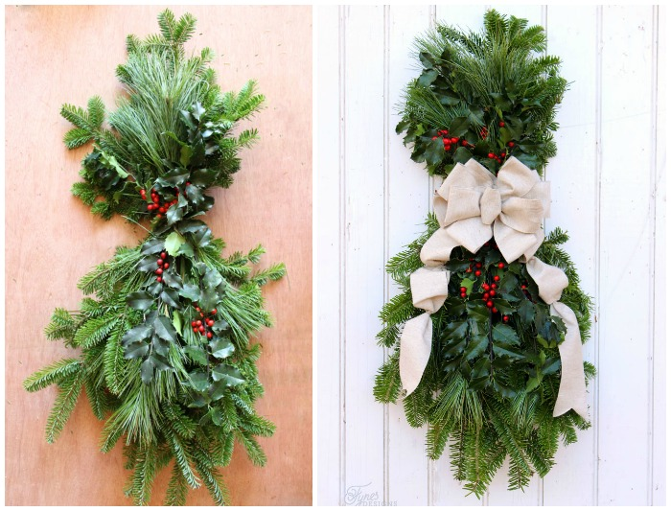
7.) Add in additional layers of cedar/ pine/ holly in the same manner as you desire. Secure with a wrap of wire with each additional layer.
8.) Embellish with ribbon, bells, pinecones, and small ornaments.
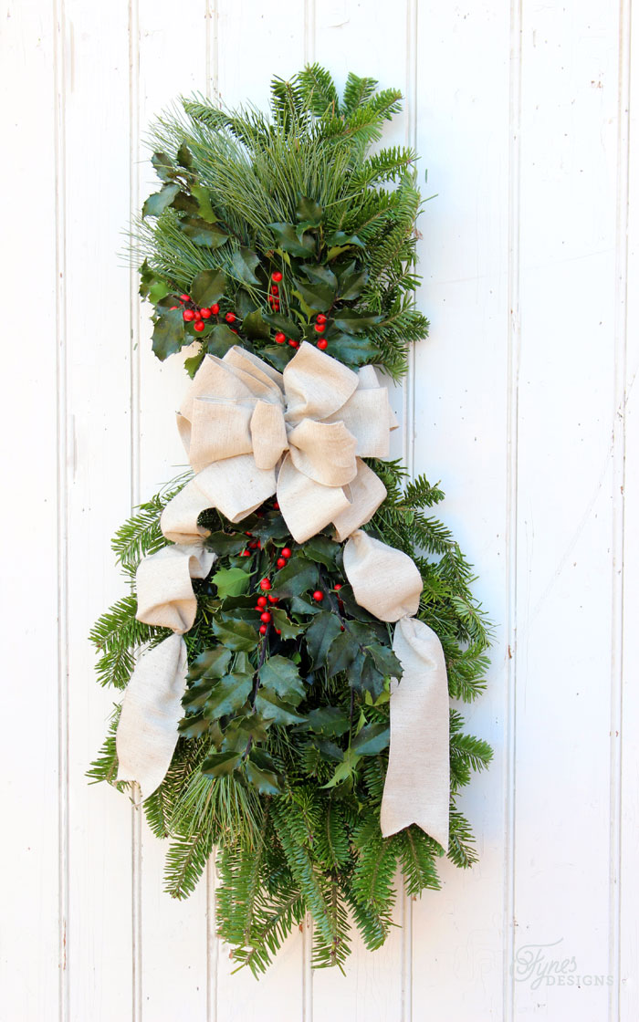
When you’ve mastered the swag, you may want to move beyond the basic bow. Below are a few tricks I use to attach ornaments.
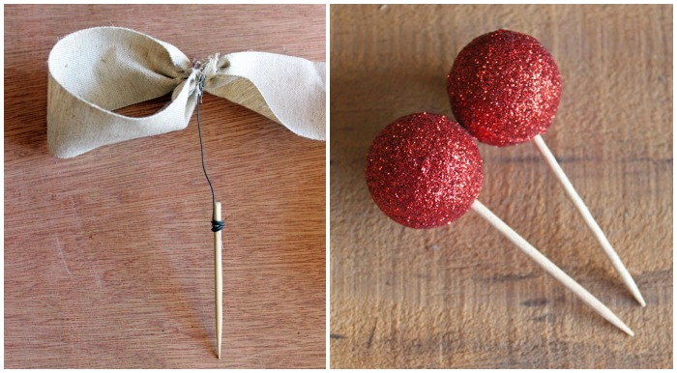
You can use toothpicks or skewers wrapped with a small piece of wire. This will allow you to poke the decorations right into the greenery.

