**[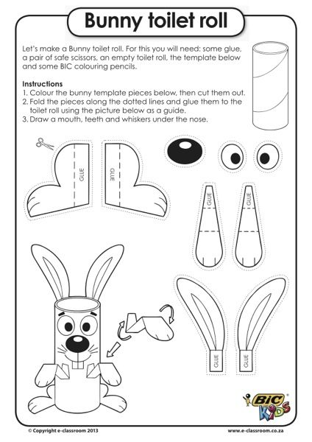](http://e-classroom.co.za/bunny-toilet-roll-easter-worksheet/)**